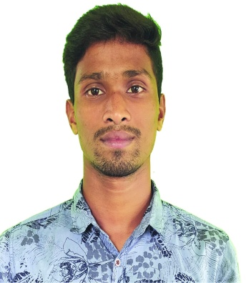
CURRICULUM VITAE
OF
Md. Khaleduzzaman
Mobile: 01949364775
E-mail:mdkhaleduzzaman75@gmail.com
Contract Address: East-Arichpur, Monnunagar-1710
Tongi, Gazipur.
OBJECTIVE

My objective is to build up a career, which is not merely a means of living but rather a means
for making life meaningful and satisfying. I believe that my academic degree and Experience
will provide me necessary knowledge to address challenging situations at my work place and
in the process, will also help me to pursue a successful career.
EDUCATION AND CREDENTIALS

Secondary School Certificate (S.S.C.)
Institute : Jalsuka Kumudgonj High School
Department : science
Result : 4.89
Passing year : 2016
Board : Dhaka
Higher School Certificate (H.S.C.)
Institute : Alomgir Monsur(Mintu) Memorial College
Department : science
Result : 3.33
Passing year : 2018
Board : Dhaka
Bsc.in Honners (Professional)
Institute : UCASM (UNDER NU)
Department : C.S.E.
Result : Appread
Passing year : 2nd year, 5th semester (Running)

COMPUTER SKILL

- Operating System : Windows -XP, Windows 7, Windows 8, Windows 10,
- Application Package : MS-Word, MS -Excel, MS- PowerPoint.
- Internet : Internet browser, Download, Emailing, Etc.
- Adobe : Ps, Pr, Ai, Etc.
LANGUAGE SKILLS

Good command over reading, writting, listening and speaking in Bengali, English.
PERMANENT ADDRESS

Vill : Uykhanda P.O. : Nobo-Balijuri
P.S. : Gouripur Dist. : Mymensingh
PERSONAL PROFILE

Name : Md.Khaleduzzaman
Father’s name : Md.Abu chand Mia
Mother’s name : Mst.Anowara Begum
Date of Birth : 11-12-2000
Nationality : Bangladeshi by birth.
Religion : Islam
Marital status : Unmarried
Blood Group : B+
Height : 5 ft. 8 Inchs
Weight : 60 KG
DECLARATION

I declare that all the information included here are true to my knowledge. If required and
where application, this document can be supported by appropriate authentic certificate.

Date……………………… Signature

