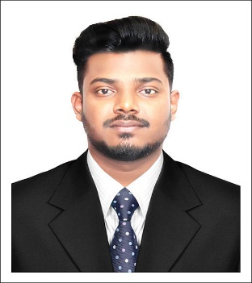
Resume

Of
Gazi Mehedi Hasan
Mobile: +8801967941003
Email: tushar.gazi69@gmail.com

House no. 41, Road no 19
KHILKHET, DHAKA-1229

CAREER OBJECTIVE
Looking forward to work in a renowned organization where I will able to utilize my knowledge, skills and abilities effectively & efficiently through challenges, dedication and growth-oriented activities under an excellent work environment specially to build up a bright career.

Bachelor of Science (B.Sc) in Textile Engineering
- Name of Institute : Primeasia University
- Department : Textile Engineering
- Result : 3.27 out of 4.00 ( on going)
- Passing Year : 2022

Higher Secondary Certificate (H.S.C)
- Name of Institute : President Professor Dr.Iajuddin Ahmed Residential Model School & College
- Group : Science
- Passing Year : 2017
- Result : GPA 3.75 out of 5.00

• Board : Dhaka

Secondary School Certificate (S.S.C)
- Name of Institute : K.K.Govt.Institution
- Group : Science
- Passing Year : 2015
- Result : GPA 4.00 out of 5.00
- Board : Dhaka

LANGUAGE PROFICIENCY
- Bengali : Mother tongue, fluent in all the language skills.
- English : Fluent in all language skills to carry the work in progress in all sectors.

COMPUTER LITERACY
- Microsoft Office : MS-Word, MS-Excel, MS-Power Point, Microsoft Outlook.
- Browsing Internet : Chrome, Firefox, inter net Explorer.
- Programming Language: Have a basic knowledge on C programming & Visual basic.

EXTRA CURRICULUM
- National Debater & Vice President of Primeasia University Debating Club.
- Founder Vice President of Youth Career Institute, Primeasia University.
- Campus Ambassador, Hult Prize Bangladesh.
- Campus Ambassador, Cyber Crime Awareness Foundation.

PERSONAL INFORMATION
• | Name | : Gazi Mehedi Hasan
• | Father's Name | : Abdul Aziz Gazi
• | Mother's Name | : Rawshan Sultana
• | Present Address | : House:41, Road:19, Nikunja-2, Khilkhet, Dhaka-1229
• | Permanent Address | : Manikpur, Munshiganj sadar,Munshiganj
• | Date of Birth | : 02/11/1998
• | Nationality | : Bangladeshi (By Birth)
• | Gender | : Male
• | Blood Group | : O+
• | Marital Status | : Single
• | Religion | : Islam

I do hereby declare that the above statements mentioned in my resume are true and correct to the best of my knowledge and belief.

Gazi Mehedi Hasan
Signature

