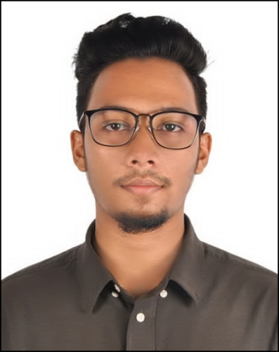
CurriculumVitae
Of

TANJIL NUR AHAMMED
Samanta Villa, (4th Floor),

House # 32, Road # 04, Sector# 10, Uttara, Dhaka

Mobile Phone: +8801624-443700

+8801309074521

E-mail:t.tanjilahammed12345@gmail.com
Sex: Male |Date of birth:17th December 1999 | Nationality:Bangladeshi.

Personal Statement

Career Objective

I am a dedicated, organized and methodological individual having a positive attitude to solve problem. I have an active and dynamic approach to work and getting things done. I am reliable trust worthy and flexible individual who is keen to learn new skills easily and execute them swiftly.
To build up a leadership career, where I show my extreme potentialities to attain the ultimate organizational goals, not only my best service and care but also providing the sign of honesty, sincerity and accountability which will assist me to play a key role to ensure the further growth of my profession as well as organization.

Career Summary  Job Experience | Position : Forever Business Owner (FBO)  Organization : Forever Living Products Ltd, Bangladesh  Jahangir Tower, Level-3, Panthapath, Dhaka  Duration : 2018 - 2021

Responsibility:
- Marketing china Shoes online based.
- Collect customers/partners need and information
- Informed to the relevant department or sector
- Initiate to solve problem
- Ensure appropriate service to the stakeholder/wholesaler from the company.

Educational
Qualification

Exam Title | Major | Institute | Result | Pass. Year | Duration
BBA | BBA Basics | Northern University Bangladesh, Dhaka Main Campus | CGPA: 3 | Pass 7 semesters, up to June 2021 | 2 years and 7 months running
B.Sc in AMM | (Apparel Merchandising and  Management) | BGMEA University of Fashion and Technology  (BUFT), Asulia Campus, Dhaka. | CGPA: 2.67 | Pass 2 semester,2018 - 2019 | 1 year
HSC | Business Studies | Biam Model School & College | GPA - 4.67 | 2017 | 02 Year
SSC | Business Studies | Bogura Zila School  Secondary Secondary Certificate (SSC) | 4.11 | 2015 | 02 Year

Personal Skills

- Highly motivated and eager to learn new things.
- Strong motivational and leadership skills.
- Ability to produce best result in pressure situation.
- Excellent to work as individual as well as in group.

LanguageSkills

- Bangla: Native
- English: Good Proficient in Reading, Writing and Speaking

Computer

Proficiency

Good proficiency on computer in the field of -
    - Photoshop
    - Illustrator
    - Power point
    - MS Word and MS Excel

Personal Details

      - Name : Tanjil Nur Ahammed
      - Father : Sakil Ahammed
      - Mother : Mst. Gole Nahar Ahammed
      - Permanent Address : Village- Jumar Bari, Post Office- Jumar Bari
Upazilla- Saghata, District- Gaibandha.
      - Present Address : Samanta Villa, (4th Floor), House # 32, Road # 04,
Sector# 10, Uttara, Dhaka
      - Mobile Phone : +8801624-443700
      - E-mail Address : t.tanjilahammed12345@gmail.com
      - Date of Birth : 17December 1999
      - Nationality : Bangladeshi by born
      - Religion : Islam (Sunni)
      - Gender : Male
      - Marital Status : Unmarried.

Reference

- Sakil Ahammed PhD
Capacity Building Director,
HARHCB Project of Australia Aid, HELP Cox’s,
Cox’s Bazar, Bangladesh.
Phone +8801712 216515
Email: drsakil.ahmmed@gmail.com

- Benazir Rahman Safa
Senior Co-ordinator
Assistant Professor
Northern University Bangladesh
Phone +8801755 513144

Certification

I certify that all of information stated in this resume is true and complete to the best of my knowledge.

Tanjil nur Ahammed

