CURRICULAM VITAE
OF
MASBAH UDDIN FAHIM
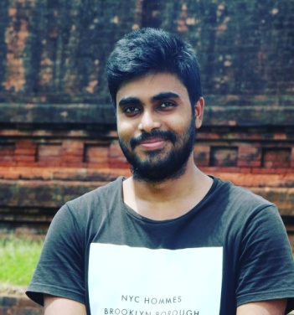
Mailing Address
Jatiya Kabi Kazi Nazrul Islam University
Trishal, Mymensingh-2220
Email: m17fahim@gamil.com
Mobile: 01518371171

Professional objectives
I want a suitable position in a social and cultural organization which demands the feelings of dedicate, honesty, dynamism and the team aspects which offers the opportunity of career growth based on performance and achievements.
Personal Attributes
- Hard working ability.
- Exactitude and promptitude.
- Ability to work independently as well as team member.
Education Qualification
- Running study in Bachelor of social science (BSS)under the department of Folklore at the Jatiya Kabi Kazi Nazru Islam University.
- H.S.C in Humanities, GPA-4.08, Chittagong college, Chittagong Board, 2015.
- S.S.C in Humanities, GPA-4.69, Al jayatul falahia kamil Madrasaha, Dhaka Board, 2013.
Voluntary Work Experience
- Working as a volunteer, Chittagong Association,(JKKNIU)
- Working as a volunteer, Green campus, (JKKNIU)
- Working as a volunteer, Selim al din natto utshob, Bangladesh shilpokola academy, Dhaka
Extra curricular activities
- Cadet of Bangladesh national cadet cor (BNCC)
- Working as a Member of somokal surid somabsh (JKKNIU)
- General Member of Green campus (JKKNIU)
- Working as a General Member of Research club (JKKNIU)
Personal Information
Name: Masbah Uddin Fahim
Father’s Name : MD.Yousuf
Mother’s Name : Nasima Akter
Date of Birth : 24 october 1996
Blood Group : o+(positive)
Religion : Islam
Marital Status : Unmarried
Nationality : Bangladeshi
Permanent Address : East Shiluya-1200, Chagolnaiya , Feni
Present Address : Chorpara, Trishal, Mymensingh-2220
Computer Proficiency
Microsoft Office Application (MS word, MS excel, MS powerpoint)
Language Proficiency
Bangla, English, Arabic, Hindi
References
Md. Baki Billah(sakar Mustafa)
Assistant professor and Head of the Department
Department of folklore
Jatiya Kabi Kazi Nazrul Islam University
Email: sakarmustafa1992@gmail.com
Acknowledgement
“I, undersign do hereby declare that all information stated in this curriculum vitae is true, correct and complete to the best of my knowledge and belief.”

