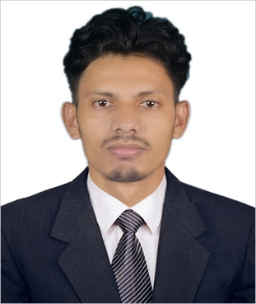
Curriculum Vitae
Of
Sayed Bin Hossain

Name : Sayed Bin Hossain
Cell : + 8801625189254
E-mail : sayedbinhossain5272@gmail.com

Career Objective:
To enter into an organization and to perform effectively as well as efficiently with my personal abilities and education, at the same time to contribute to the nation and society.

Academic Qualification:
Education Level : Masters of Business Administration (MBA) (Running)
Major : Finance
Semester : 1st
Name of Institution : BGC Trust University Bangladesh
Duration : From July, 2017 to June, 2021

Education Level : Bachelor of Business Administration (BBA)
Major : Finance
Semester : 8th (Last Semester)
Result : 3.40 Out of 4 (CGPA) up to 7th Semester
Name of Institution : BGC Trust University Bangladesh
Duration : From July, 2017 to June, 2021

Education Level : Higher Secondary Certificate (HSC)
Group : Commerce
Result : 2.50 Out of 5 (GPA)
Name of Institution : BGC Trust School and College
Name of Board : Chattogram Board.
Passing Year : 2016

Education Level : Secondary School Certificate (SSC)
Group : Science
Result : 3.88 Out of 5 (GPA)
Name of Institution : North Satkania A.P High School
Name of Board : Chattogram Board.
Passing Year : 2014

Major Courses Completed:

- Financial Institutions & Markets
- International Finance
- Financial Management
- Business Policy & Strategic Management

ADDITIONAL INFORMATION

Computer Knowledge:
Application Software | MS Word, MS Excel, MS Power Point
Internet | Web Browsing & E-mail

Personal Information:
Father’s Name : Ahmed Hossain
Mother’s Name : Farida Begum
Present Address : Satkania, Chattogram
Permanent Address : Molobir Dokan, Satkania, Chattogram
Upazila- Satkania, District- Chattogram.
Date of Birth : 1st January, 1998
Religion : Islam
Marital Status : Unmarried
Blood Group : A+
Nationality : Bangladeshi by birth

Declaration:
I do hereby declare that all of the above information are true and correct to the best of my knowledge. I ensure that, I have no problem in case of verification of the provided information.

References:
2. Shahed Bin Hossain
Mutual Trust Bank Ltd.
Asst Relationship Manager, Retail Banking Division
- Salah Uddin Shariar
Deputy Register
Bgc Trust University Bangladesh

