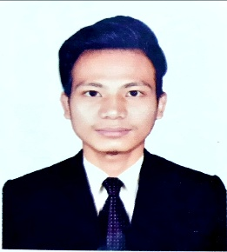
Personal Details:
Name : Ranghin Mro
Father’s Name : Younglong Mro
Mother’s Name : Kaidui Mro
Date of Birth : 19th July, 2000
Sex : Male
Permanent address : Lamar Para, Sualock, Bandarban
Present address : Kalaghata, Bandarban
e-mali : ranghin15@gmail.com
Contact number : +8801614196230
Career Objective:
To be an expect employee and intend to work in a challenging and competitive environment in an organizational position entrusted with higher responsibility and strategies decision making authority. Self motivated driven creative with proactive.
Language skills:
Mro, Bengali, English.
Academic Qualification:
Exam title | Group | Institute Name | GPA | Passing year
SSC | Science | Mro Residential High School | 3.50 | 2016
HSC | Science | Bandarban Govt College | 2.92 | 2018
BSc in Computer Science and Engineering at Bandarban University (4th Year)
Training summary:
Tarum Foundation, Bandarban
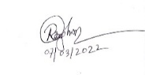
Date: 16 march, 2022 Signature

