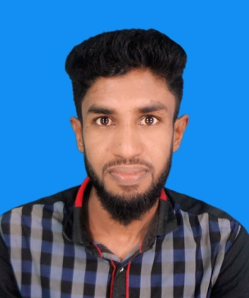
CURRICULUM-VITAE
Md. SolaimanMollah
Diploma in Environmental Engineer
Mobile No: 01751-447273
: 01611-147273
E-mail: sulaymanmollah@gmail.com

SCHOLASTIC RECORDS | Degree  Institute  Group  Board  Year of passing  CGPA  Degree  Name of School  Board  Group  Year of passing  CGPA | : Diploma-in-Engineering  : Barguna Polytechnic Institute, Barguna.  : Environmental Technology  : Bangladesh Technical Education Board, Dhaka.  : 2018  : 3.25(out of 4.00)  : Secondary School Certificate (S.S.C)  : Jhanjhania high school  :Jessore  : Business studies  : 2013  : 4.19(Out of 5.00)

PERSONAL INFORMATION | Father’s Name : Md. EusufMollah  Mother’s Name : Anowara Begum  Date of Birth : 01-06-1996  Place of Birth : Rampal, Bagerhat  Sex : Male  Religion : Islam  Marital Status : Unmarried  Blood Group : O+  Nationality : Bangladeshi (By Birth)

COMPUTER  LITERACY &Experience | - AutoCAD (2D)  - Microsoft word, excel, power point.  - Internet Browsing, E-mailing.  - (ETP Bio-Chemical) Plant Operator (8Month Experience)  - (WTP) Running Job WaterClean (1 Year)

PERMANENT ADDRESS | Md. Solaiman Mollah  Vill: JhanJhania  P.O: JhanJhania  P.S: Rampal  Dist: Bagerhat  Mobile:01751-447273

Declaration | I am confident and having the ability to work at high place on one’s own imitative. I will try to Perform my best in duties according to the desired satisfaction of the authority and speed up my accuracy.

I am undersigned, hereby declare that I will be responsible for any wrong information providedhere.

.................................
Md. SolaimanMollah

