Curriculum Vitae
G.M NAZMUL HUDA

Career Objective:
To enter in a well organization in a suitable position having the invention to work with honesty, sincerely and to learn, grow and eventually take greater responsibilities and face the challenges of the again experience & skill successful career.
PERMANENT ADDRESS: pRESENT ADDRESS:
Vill & Post: Puijala, 12/C, Nasu Vila
P.S: Assasuni, Dist: Sathkira. Azimpur, Dhka-1205.

Contract Number
01840881134

Academic qualification

BA (Honour’s)

- Institute Name : Jagannath University, Dhaka
- Subject : Islamic Studies
- Year : Running (2nd Year)

Higher Secondary Certificate (H.S.C)

- Institute Name : Bangladesh Krira Shikkha Protishan (BKSP)
- Group : Humanities
- Result : GPA- 3.58
- Board : Dhaka
- Year : 2018

Secondary School Certificate (S.S.C)

- Institute Name : Bangladesh Krira Shikkha Protishan (BKSP)
- Group : Humanities
- Result : GPA- 4.11
- Board : Dhaka
- Year : 2015

Computer Skill:
Word Processing and Documentation: MS-Word, Internet Browsing.

Language Skill:
Good written oral communication ability in Bengali and preliminary ability in English.

Personal Details:

Father’s Name : Md. Abdul Hamid Gazi
Mother’s Name : Fazila Khatun
Date of Birth : 31/12/1998
Religion : Islam
Nationality : Bangladeshi by birth
Sex : Male
Blood Group : O+
Marital Status : Unmarried

Self assessments

- Hardworking, Discipline and Steady.
- Better learning Capability.
- Keen eyesight and better sound analytical ability.
- Better ability to take the duties, responsibilities and pressures.

Declaration

I do hereby declare that the above information is true and correct to the best of my knowledge.
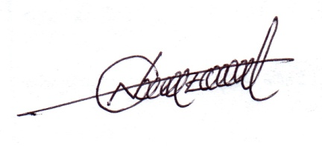

G.M. Nazmul Huda
Date:

