Curriculum Vitae (CV)
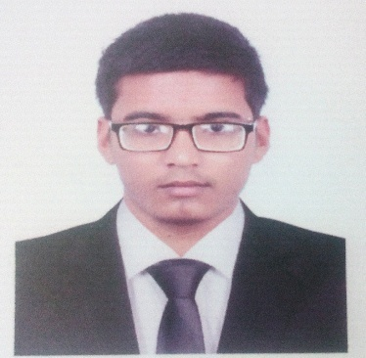
Md. Shahinur Islam
Contact Address : Room no. 346, Sayd Amir Ali Hall, University of Rajshahi, Motihaar, Rajshahi.
Cell phone : +8801791811477
Email : shahinmcj27@gmail.com

Career Objective:
Youth activist in a creative, energetic and discerning environment atmosphere conducive to exploring, researching, reporting and communicating for Youth Opportunities and researched information in the best possible way utilizing acquired social activity skills.
A drive to perform, patience, accepting challenging work, willingness to learn.
Personal Information:
- Name | : Md. Shahinur Islam
- Fathers name | : Md. Sadequl Islam
- Mothers name | : Mst. Sultana Begum
- Permanent address | : Vill: Jagannathpur-611, P.O: Thakurgaon, P.S: Thakurgaon Proper ,Dist: Thakurgaon.
- Nationality | : Bangladeshi
- Date of Birth | : 15-06-1998
- Age | : 23
- Religion | : Islam
- Marital Status | : Single
- Sex | : Male
- Blood group | : B+ve
Educational Qualification:
:

Education
- Name of the exam : B.S.S Honor’s (Mass Communication & Journalism)
Result : 3.30 out of 4.00
University : University of Rajshahi
- Name of the Exam : Higher Secondary Certificate (H.S.C)
Group : Science
Result : 3.83 out of 5.00
Passing Year : 2016
College : Birganj Govt. College
Board : Dinajpur

- Name of the exam : Secondary School Certificate (S.S.C)
Group : Science
Result : 4.50.out of 5.00
Passing Year : 2014
School : Ibrahim Memorial Shiksha Niketon
Board : Dinajpur
Computer Skills:
Work Experience

- Worked as an Editor at online news portal Bartajogot24.com from January 2018 to December 2018.
- Worked as a Reporter at Daily Rajshahi Sangbad newspaper
from July 2018 to June 2020.

Volunteering Experience
- 2 years of volunteering with Rajshahi University Education Club as a joint secretary by helping students build up their base for achieving qualitative education.
- Founder and President of Development Club of Youth Empowerment. Objectives of this organization is to inspire youth locals for self development providing motivatiom, information and proper training.

Writing skills: I have also worked in some local newspaper, online news portal and wrote feature stories in national newspaper. And also as Feature Contributor at National and Local Newspapers.

Special Skills
- MS Office Package Program(MS Word, MS Excel, MS Power point, MS Access)
- Adobe Photoshop, Illustrator, Quark X Press
- Internet Operations
- English – Well versed in both written and spoken English
- Polyglot in Espanol, Arabia, Desutch and Turkce.
- 2 year experience in reporting and editting.
- Adaptable with any situation and atmosphere.

I, hereby, declare that each of the information stated above is true and any intentionally made mistake will result me in disqualification.
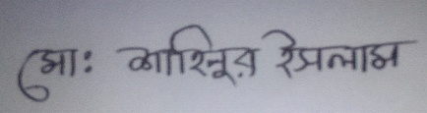
………………………
Md. Shahinur Islam

