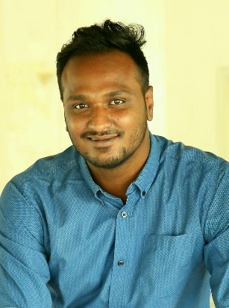
MD.SHEIKH RONY HOSEN
Adress: 138,West Nakhalpara,Tejgaon,Dhaka
Mobile: +8801777490005
E-mail: hossainrony806@gmail.com

OBJECTIVE
To work with an environment where I can exercise creativity and innovation. Im ready to work hard so that I can lead a standard life and also develop a career in a environment where there is an opportunity to improve the life of other.
EXPERIENCE
• Multimedia projector operator.
• Videographer.
• Assistant photographer.
• Photographer.
• Senior camera person.
• Canteen supervisor.
Strength Skill and Abilities
• Good Communication and Presentation ability.
• Can Work Under Pressure.
• Can Work Independently and as member of any team.
• Having good skill in planning organizing and monitoring.
• Strong work ethic under pressure.
Language Skills
• Excellent speaking and writing in Bangla.
• Excellent speaking in Urdu.
• Excellent speaking and writing in English.

Personal Information
Name : Md.Sheikh Rony Hosen
Father’s Name : Md.Sheikh Anowar Hosen
Mother’s Name : Ranu Begum
Date of Birth :06/04/2001
Nationality : Bangladeshi
Religion : Islam
Marital Status : Unmarried
Gender : Male
Blood Group : 0+
Height : 5’11”
EDUCATION
Degree | Board | Passing Year | Institute | GPA
JSC | Dhaka | 2015 | Rashidpur High School | 4.28
SSC | Dhaka | 2017 | Soheed Monu Mia High School | 3.68
HSC | Dhaka | 2020 | Dhaka Oriental College | 3.08
Honours | Dhaka | Continued | DU Affiliated Bangla College

Signature

