Resume  Of  Md. Tariqul Islam | 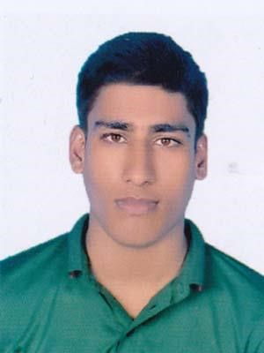

Contact number: 01740344771
Email address: tariqulislamtareq49@gmail.com

OBJECTIVE
To obtain a entry level position and develop a challenging career where I can make a meaningful contribution with deep credence and grow professionally with integrity, objectivity and accountability.

PRIOR EDUCATIONAL STATUS:

Bachelor of Arts(BA)
CGPA : Study is Running
Department : Pali and Buddhist Studies
Session : 2019-20
Institution : University of Dhaka

Higher Secondary Certificate (H.S.C)
GPA : 4.83
College : Rangpur Government City College
Section : Humanities
Board : Dinajpur
Year : 2019
Secondary School Certificate (S.S.C)
GPA : 4.68
School : Mohishmury High School
Section : Science
Board : Dinajpur
Year : 2017

COMPUTER LITERACY

➢ Operating system: windows XP/2007/2010.
(Ms-Word, Ms-Excel, Ms-Power Point)

LANGUAGE SKILL
Language | Reading | Writing | Spoken
English | Excellent | Excellent | Good
Bangle | Excellent | Excellent | Excellent

PERSONAL INFORMATION
Father’s name : Md. Jahangir Alam
Mother’s name : Most. Tahmina Begum
Present address : Master da Surjasen Hall, University of Dhaka, Dhaka-1000
Permanent address : Vill: Mohishmury P/O: Sundar
P/S: Pirgachha Dist: Rangpur
Date of birth | : 15th February, 2002
Nationality | : Bangladeshi (by birth)
Marital status | : Unmarried
Religion | : Islam
Blood Group | : A+

Reference:

Name | Dr. Shantu Borua | Name | Md. Aktaruzzaman
Designation | Assistant Professor | Designation | Assistant Professor
Department | Pali and Buddhist Studies | Department | History
Address | University of Dhaka | Address | Rangpur Govt. City  College
Mobile | 01816653169 | Mobile | 01711231050
Email | baruashantu82@yahoo.com | Email

DECLARATION

I, the undersigned declare that the information specified in this CV is true to the best of my belief and knowledge and correctly describes my experience and myself.

Sincerely yours

