Curriculum Vitae

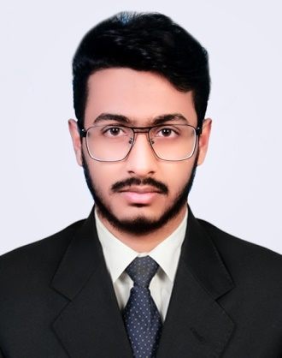

Name : Abdur Rahman Shuvo
Father’s Name : Babul Mollah
Mother’s Name : Kulsom Akhter
Permanent Address : Daudkandi, Comilla
Present Address : Daudkandi, Comilla
Mobile Number : 01300471756
Date of Birth : 13 July 2002
Gender : Male
Married Status : Unmarried
Nationality : Bangladeshi
Educational Qualification
Degrees | Group | Board | Pass. Year | Result (GPA)
S.S.C | COMMERS | Comilla | 2018 | 4.54 out of 5.00
H.S.C | COMMERS | Comilla | 2020 | 4.61 out of 5.00

Now studying at, Jagannath University, Department of Economics
Extra Qualification
Member at Jagannath University Feature, Colum & Content Writers
Member at Jagannath University Economics Career Club
Member at Jagannath University Debating Club
Online Blog Writers at Climate Change
Works at online photography page “Bird Collection”

