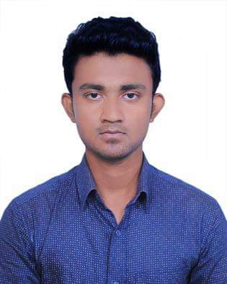
Resume
of
Md. Aminur Rahman Sefat

Personal Information:
Name: Md. Aminur Rahman Sefat
Address: Village: Chargarabdi, P.O.: Chargarabdi
Thana: Dumki, District: Patuakhali
Post code: 8602
Contact: +8801866485938
Email: arsefat9@gmail.com
Date of birth: 20/05/1999
Gender: Male
Marital status: Unmarried

Academic details:
Institution name: Bangladesh University
Degree: Bachelor of Arts in English literature
Current Cgpa: 3.73
Season: Summer-2019
Year of passing: 2023(pursuing)

Work experience:
Organizations: BUECSC
Designation: General Secretary
Duration: March 2022 - March 2023
Project details:
Title: BUECSC Cricket Carnival 2022
Description:
The BUECSC Cricket Carnival 2022 is a one-day tournament in which five teams take part in the tournament, with each team consisting of 9 boys and 5 girls.
Duration: One day tournament
Number of teams: 5
Role: Tournament management

Extra qualifications:
★ I am able to handle multiple tasks on a daily basis
★ I use a creative approach to problem solve
★ I am a reliable person who is great at time management
★ I am always energetic and eager to learn new skills
★ I have experience working as part of a team and individually
★ I am flexible in my working hours, being able to work evenings and weekends

Reference details:
Name: Sheikh Alauddin
Designation:
Head of the Department of English and Chief adviser of BUECSC
Institution name/Organization:
Bangladesh University/Department of English/ BUECSC
Contact: +8801755559302
Email: alauddinbu1957@gmail.com.

