CURRICULAM VITAE
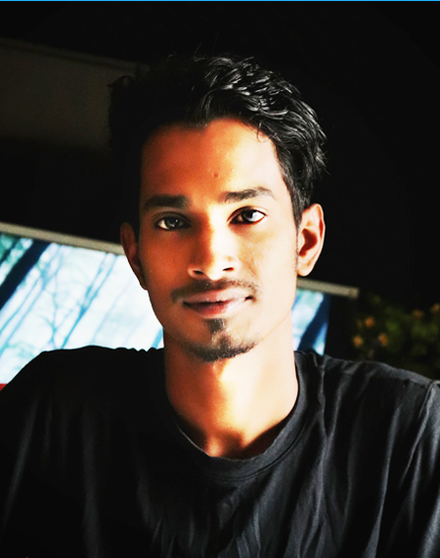
Photo
MD. FOZLA RABBI
Contact: 01309-074493
E-mail: fozlarabbi568@gmail.com
Personal information:
- Name : Md. Fozla Rabbi
- Father’s name : Md. Ashadul Islam
- Mother’s name : Parul Akter
- Permanent Address : Vill: Borochala P.O: Paragaon-2240
P.S: Bhaluka, Dist: Mymensingh.
- Present Address : Vill: Borochala P.O: Paragaon-2240
P.S: Bhaluka, Dist: Mymensingh.
- Date of birth : 26 June 1998
- Nationality : Bangladeshi (By Birth)
- Religion : Islam
- Gender : Male
- Marital Status : Unmarried
- Height : 5 Feet 8 Inch
- Weight : 53 Kg
- Blood Group : B+
- NID Number : 1030986523
Academic Certificates:
Name of Institute | Examination | Board | Point | Year
S.T Andrews High School | SSC(Science) | Dhaka | 3.94 | 2015
Gov. Bhaluka College | HSC(Science) | Dhaka | 3.25 | 2017
IUBAT | Honer’s (BSAg) | Dhaka | Studying... | 2019 Till now..
Computer Efficiency
M.S Word, M.S Excel, M.S Power Point, Internet Browsing .
Declaration: I do here by declare that the above information is true and correct to the best of my knowledge.
Signature
Date:..................... (Md. Fozla Rabbi)
Priority: NID Card

